A-Level Revision App

NEA Project

Rameen Ather

Python

NEA

Analysis 3

The problem 3

Regarding the student (main recipient): 3

*Whats the issue?* 3

*Why are these skills important?* 3

*Whats the main problem with the issue raised?* 3

*What additional factors can the affect the development of these skills?* 4

Regarding the teachers/examiner (secondary recipient): 4

Interview 5

Research for the problem 6

Similar website designs 6

*Physicsandmathtutor* 6

*Save my exam* 7

What the questions look like: 8

Solution 10

Who is the intended user/s in this project 10

Objectives 10

Design 12

Hierarchy diagram 12

What the website will look like 13

What you see first: 13

signup 14

Log-in 14

Home (Student) 15

Home (Teacher) 15

Home (Examiner) 16

Logs (teacher) 16

Login/Sign-up: 17

Class diagrams 18

Database Models 19

# Analysis

## The problem

### Regarding the student (main recipient):

#### *Whats the issue?*

In a lot of cases, for students studying a level, they struggle finding the motivation, method, time to study or just not having the skills to get better grades. Which can lead to the students not getting strong enough grades to secure them a spot in the university of their choice. These skills include things such as, time management, organisation, consistency, patience or just the motivation to sit down and work in the student’s own time. A further problem with students studying for a-level or in general without the use of these skills, is overstudying, which can cause the student to be stressed and anxious, eventually leading to a burn out and therefore a further downfall to their grades.

Researchers at Stanford did a study on the effect of over-studying on students. In which they found that students that completed *“more than 3.1 hours of homework per night experienced physical health problems, depression, sleep deprivation, academic stress and a lack of balance in their lives”*

[1]To add on, the transition from GCSE to A-Level is really tough on a lot of students because of the amount of independent study they need to do outside of lesson time. The normal independent time expected off of students is one hour per subject so 3-4 hours a day. This itself puts pressure and doubt onto the student’s mind and then the student severely lacks motivation to revise efficiently to even get good grade. In 2019[2], The Sub released an article on the A-Level maths of the year. It only took the student getting 55% to get an A and 14.7% for them to pass A-Level maths.

#### *Why are these skills important?*

The skills mentioned before are often called ‘Soft Skills’ [3] (or transferable skills) and are generally the skills that stand out to employers when going into work, and these skills are developed from the time the person is studying. Hence the important of these skills. Although when a person obtains these skills, they often gain a sense of self-motivation which further helps the person with jobs and confidence in themselves.

#### *Whats the main problem with the issue raised?*

These skills generally take a long period of time to obtain and especially an incredible amount of motivation and patience to stick through it. With having to spend time organising yourself to be able to do productive work and still have time to have fun in life, a person generally tends to ignore spending time on organising and managing their time leading themselves to work at unreasonable hours and rushing to finish work they were given from college, without being able to do revision of their own.

#### *What additional factors can the affect the development of these skills?*

(These factors are generally out of the students control or affect the student way too much for them to be able to have the patience and develop the skills)

* Lack motivation in general weather due to mental health issues or other reasons[4]
* Have learning disabilities, such has ADHD, autism, Dyslexia etc
* Students that are not able to find the proper time to organise themselves and revise properly due to personal issues.

### Regarding the teachers/examiner (secondary recipient):

When it comes to teaching and being an examiner, sometimes you need to practice questions yourself or practice marking for all the hundreds of papers that will be marked by examiners and teachers in a single year. Or just even get away from the normal teaching routine and help other students not being able to do well on their own accord

Although the main issue isnt really to do with the teachers as they already did their a-levels, they do teach it and often have a passion to help others also do well in their a-level or at the very least understand what they are learning. Often teachers want to be able to help students with their a-levels and that can be useful to a student that struggles with lack of motivation to guide them to a right path to find a way for them to get consistent.

## Interview

An interview with a biology A-level student to get an idea of how the student studies, what they do to study and how they find revision. This gave me a further idea about the problem and its effects on the students.

*How do you normally revise?*

“Read over notes, flash cards, YouTube videos and exam questions”

*Can you access these exam questions and other resources easily?*

“I mean yeah, I just look at physicsandmathtutor and get exam questions from there. Though sometimes finding specific questions can be a struggle”

*Do you know how confident you generally are in each topic for Biology?*

“I don’t know right now; I’d have to go through each topic to see and know”

*Do you struggle finding motivation to revise?*

“YES!” (Genuine reaction) “of course”

*Are you able to manage your time well when you do study?*

“If I plan out my revision properly before studying then yes, and if I don’t use my phone… ha-ha.”

*Would you say you are organised in terms of your revision?*

“In terms of my revision, sometimes? I don’t think I’m always organised so it can be hard when revising”

*After doing this interview with this student, I developed a further understanding on the problem:*

* a further conformation on how motivation is a genuine hard struggle amongst the students.
* Questions arent hard to find, but can lack being specific in what the student wants
* Students don’t generally know how confidant they are in each subject
  + being disorganised, not knowing what to focus on and what not to focus on.
* Organisation in a student’s life is needed if they want to be able to study efficiently

## Research for the problem

### Similar website designs

Websites that are meant for revision, namely physicsandmathstutor[5] (as mentioned by the student interviewed) and savemyexams[6]. These websites are some of the more popular and largely recommend website amongst the students

#### *Physicsandmathtutor*

General description of the website:

-*This website focuses on providing exam questions, notes, flash cards on each of the listed subjects.*

Analysis of these websites:

* Although it is a great website for students, my focus is on the A-Level biology and A-Level maths side of it.
* This website has its questions stored topic and subtopic wise, making it somewhat easy to find questions
* Although the number of questions that this website has for A-level biology and maths is little and often repeated in another subtopic.
  + Which adds on to what the student said in the interview about the struggles of finding specific questions.
* This website also has notes on each topic and a general cheat sheet for each topic in maths.

#### *Save my exam*

General description of the website:

-*This website has a variety of questions from simple to hard, notes on each topic and past papers.*

Analysis of these websites:

* Focusing on the maths and biology side of this, this a good website in terms or variety of questions which is not necessarily present in physicsandmathtutor.
* It gives you levels on difficulty on which you can choose which one to do

Overall, for revision this a great revision website for students.

What the questions look like: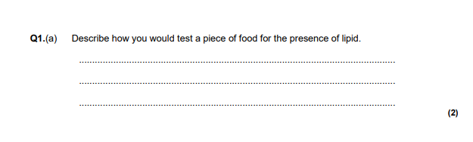

They would come with their corresponding mark scheme answer, to allow the marker, either the teacher or examiner, to mark.

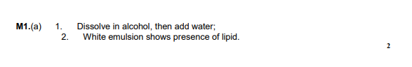

More examples:

There are a few instances where the questions are longer than a page, which can create problems, as it can be difficult keeping all of the question if in one image file. (Below is the corresponding answer)

A long question would look like this after a series of screenshotting and editing have taken place.

A lot of the questions would not require editing; however, a few are longer than a page.

## Solution

My revision website will be able to help students manage their time with quick access to questions they wish and have actual teachers there that will be able to teach them. Also, will be able to manage their self-motivation with constant reminder and easy access to questions and help.

The website will be able to provide them with quick fire questions, that they are able to answer and can either mark or have a teacher/moderator mark it and be able to do them again another day to learn what you forgot.

### Who is the intended user/s in this project

The intended end users for this website are students, specifically A-level maths, and A-level biology, due to these subjects being one of the harder subject to revise for. It is also a known fact that the jump from GCSE to A-level is harder than the jump from A-level to university, therefore a lot of students generally tend to struggle in their a-level years.

The secondary end users: Teachers will be able to use this website to teach students and mark stuff being sent to them as well as the markers being able to mark questions that the students complete.

## Objectives

* Registration and login system
  + Your able to pick from three different types of accounts: Student, Teacher, and Examiner
* 4 different types of accounts
  + **Student** 
    - on this account you can do exam questions, generated based on what topic you ask for
    - log your confidence in each topic
    - be able to be ‘taught’ by registered teacher accounts
  + **Teacher** 
    - Can also do questions that will be generated based on what topic they ask for
    - Teacher accounts will be able to teach students on listed topics
      * From which the students’ can-do quick-fire questions right after to test their memory.
      * After a while the student will be given the test again, to form a memory curve which will allow the student and teacher to see what they need to work on.
  + **Examiner/Moderator**
    - will be an account on which you can practice marking questions for the actual exam
    - Have the ability to only get a certain type of questions to mark
  + **Admin**
    - An account that will be in charge of reports for inaccurate marking, fraudulent teaching for teachers or just in general rude behaviour from any user.
    - Have the ability to block an account
* Database of questions
  + The questions would be stored in tables to their according label, for example questions about lipids would be stored in a table called lipids in the database
  + The corresponding mark scheme would also be stored in the same record in the table.
* Questions generated
  + The system will be able to generate a random test made up of the certain topic the user asked for
  + The corresponding mark scheme will also be made
  + Will be able to generate a set of questions after a teaching session with a teacher
    - These questions will be saved and sent to the student to do again another day
* An emailing system
  + Sends an email every day to all the student accounts with the recommended revision subject and a reminder to study.
* A confidence logging system
  + Student accounts are able to log confidence level in each topic through a series of range inputs and this will be stored until next time changed
  + Teacher accounts are able to log what they have taught to the students.
  + Two separate ones, one for biology and one for maths
* Being able to add images
  + The user will be able to add their answers they have done in their book as images
  + Which will be sent to another user to mark.
* A file of motivational quotes
  + That will be displayed on the home page and is random each time.

# Design

## Hierarchy diagram

This is a rough design/overview of the overall job of the website, with what accounts can do what and going into slight detail on each action.

The green at the top represents the accounts and the classes I’m going to make to each

The light blue represents what main thing each account can do, the ‘methods’ of the accounts and which one links with what accounts, for example, both student and teacher are able to do a quiz.

The blue represents what happens in each ‘method’. What the accounts will be able to in a general description.

The green -> Database

## What the website will look like

This won’t be 100% accurate to the final product as I’m not going in depth into colour designing and other frontend designing other than what the general website will look like overall. This was design using a website[7] and is not coded.

### What you see first:

During the designing process I realised that there might be some users that do not wish to do one of the subject, maths, or biology, and therefore having access to questions and help from that subject would be useless, that’s why I added an option at the start to let you choose weather you want to do one or both the subjects.

This is what would be shown first, it gives you an option to choose whether you want to do math, biology, or both and then leads you to be able to sign in.

**Login**

### signup

Sign-up page. There is an option for the user to pick what type of account they want, student, teacher or examiner and then lead you to a home page corresponding to the account.

### Log-in

Log-in page. User logs in.

### Home (Student)

This will generally be how the home page looks and what you will be able to do with it. The logs button will lead you to a page that will allow you to pick between a range of how confident you are in each topic. The help will lead you to a page where you will get put in touch with a teacher to help you with whatever the student needs. Lastly the quiz button will lead you to a page where you can pick what kind of question you wish for.

### Home (Teacher)

### Home (Examiner)

The examiner won’t have much stuff going on other than marking questions done by students or teachers and giving them back.

## Login/Sign-up:

Get asked for your status e.g student, teacher, examiner and your subject, maths or biology.



## Class diagrams

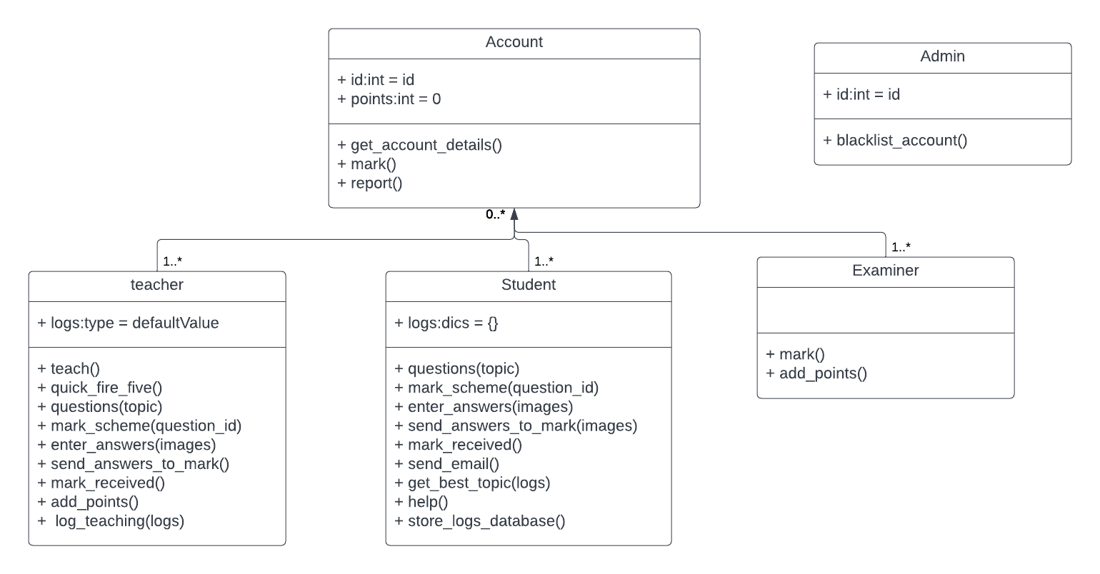This is how the general layout of the class system will be. This is what all the accounts will be able to.

### Student



#### Questions(topic_selected)

In this method the student will be able to give a topic and using database query, a series of questions will be picked out from the database containing the questions

SELECT id, question, answer

FROM questions

WHERE topic = topic_selected

ORDERBY marks

With randomly generated numbers 10 or so questions will be picked and then be put onto another table of the database: questions_mark, which will then record the date these were generated.

Inserting into the table with example values

INSERT INTO account_answer (acc_id, QA_id, date_entered, question, topic, marks)

VALUES (self.id,23, 05/10/22, question, proteins, 0)

Marks will automatically be set to 0 until the questions have been marked by the user themselves or another account and that has been entered into the system then answer attribute will be filled when the someone has marked the questions and have submitted them into the system.

#### Mark_scheme()

If the user asks to mark the questions themselves the mark scheme of these questions will be selected from the questions_mark table and be shown to the account.

SELECT answer

FROM questions_mark

WHERE date = current date

ORDERBY marks

And from this the latest 10 will be selected as there is a chance that the user tries to do more than 10 questions a day.

#### Enter_answers()

This will allow the users’ answers to be stored in the database to be sent to another account to be marked. This happens by the account entering images of there answers and using this method they will be stored in a database table account_answers.

Updating the record with example values

UPDATE account_answers

SET answer = answer_image

WHERE acc_id = self.id, QA_ID = 23, date = 05/10/22

#### Send_answers_to_mark()

This method will first look for someone in the database that has a priority for this topic for marking and if there is none, it will look for someone else that is willing to mark some questions at the moment and the send the questions to them.

SELECT acc_id, email, status

FROM account

WHERE topic_priotity = topic and willing_to_mark = yes

#### Mark_received()

When the marking of the questions is done by another person, they will submit marks received in each question and this method will then update the database table: account_answer mark section to corresponding marking.

UPDATE account_answer

SET marks = 3

WHERE acc_id = user_id and QA_id = QA_id

There will be points where the user does the same questions more than one time on different occasions and both of them will be saved as they can show a learning curve for the teacher when seeing the results from the students attempt at the questions.

#### Send_email()

This method will take the student accounts email and send them an email reminding them to revise

SELECT name, email, topic_ priority

FROM account

WHERE status = student

#### Get_best_topic()

This method will go through an algorithm to find the most ideal topic for the student to revise for the week.

Algorithm to be decided (not finished yet sorry)

#### help()

Goes through all the teachers in the database and selects a teacher and sends the teacher an email to conform or deny there availability to teach.

SELECT *

FROM account

WHERE status = teacher

#### store_logs_database()

Once the student enters how confident they are in the logs page, this method will be called to allow all of them to be taken and be put into a database

Entering into the table with example values

INSERT INTO topic 1 (acc_id, date, lipids, carbohydrates, proteins and enzymes, DNA , ATP, water and inorganic molecules )

VALUES (user_id, current_date,23,54,75,87,34,88)

### Teacher



Teach()

Log_teaching()

Quick_fire_five()

Questions()

Mark_scheme()

Enter_answers()

Send_answers_to_mark()

Mark_recevied()

Add_points()

### Examiner

## Database Models

This is to show how the data will be stored in the databases and how the tables will be organised, what table will have what attribute and what are the primary and foreign keys

The database table for saving the details about an account.

|  |  |  |  |  |  |  |
| --- | --- | --- | --- | --- | --- | --- |
| ID | First name | Second name | Email | Password | status | Subject |
|  |  |  |  |  |  |  |

First attempt at making the overall database

After the first attempt I realised that I wanted the questions table to be connected to the overall database.

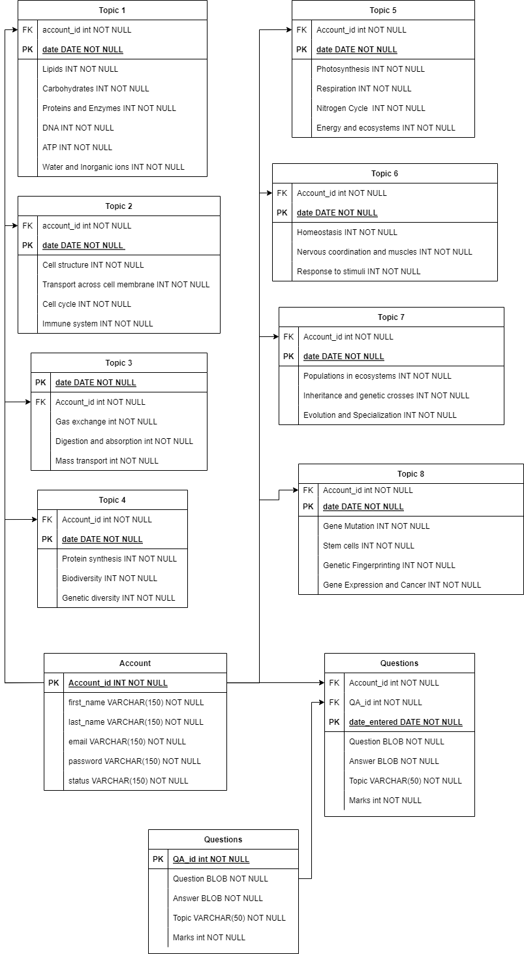

The students being able to pick what topic they want to work with.

During designing a problem came up about the users that do not wish to study one of the listed subject, they will sort of be forced to have access to something they do not have use to so…

1. <https://thinkstudent.co.uk/how-hard-is-a-level-biology/>
2. <https://www.thesun.co.uk/news/9724339/a-level-maths-exam-grade-boundaries/>
3. <https://resources.workable.com/hr-terms/what-are-soft-skills>
4. <https://mobilehealthdata.com/effects-of-mental-health-on-academic-performance/>
5. <https://www.physicsandmathstutor.com/>
6. <https://www.savemyexams.co.uk/>
7. <https://webflow.com/> (how the website will look was made using this)